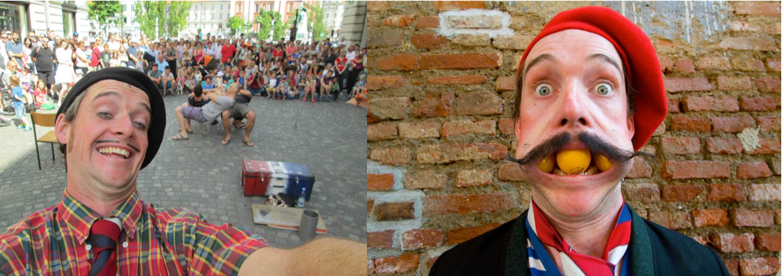
Dan le Man - ‘’Pour Femme’’

Info and Technical Rider (Outdoor, Festival Show)

Bio
Dan Renwick has studied Circus Skills in England, Physical theatre in Australia, speaks German, lives in Estonia, plays a French character, eats Belgian chocolate, wears trousers from Italy and learns Mandarin from a Japanese lady who likes to holiday in Guatemala. Oh and he also makes his own brand of perfume!

His unique style of wordless performance has been seen from Brazil to Russia and lots of places in between; on stage, in the street and in the bathroom. From 5 - 40 minutes, Dan le Man is an all ages perfomer who will get you jumping, bungee style off the cliff of laughter and giggles

‘’Pour Femme’’
With weird circus stunts, silly magic tricks, positive audience participation, ping pong ball mouth juggling and head shakingly interesting physical comedy, ‘’Pour Femme’’ is an all ages show that will leave you giggling with delight. All performed without uttering a single word.

Technical
Performance Area : Min 6 x 4m (on the ground/street)
Electricity : Not required
Setup : 0 mins
Pulldown : 5 mins
Duration : 40 mins
Number of Performers : 1
Technicians Required : 0
Language : Wordless
Special Request : 4 chairs, without armrests
Maximum Number of Shows per day : 3
Sound Level of Show : Low - Medium

** Show is best played without other ambient sounds from nearby **
** No copyright material is used **

Teaser Video : https://youtu.be/lzJspN-JPKQ

Email : dan@dan-le-man.com
Website : www.dan-le-man.com
Facebook : www.facebook.com/danlemanArtist

Photo Credits : Dan Renwick, Emmanuel Cristallo

